**User manual**

Contents

1. Prerequisites 1

2. Pages 1

3. Web Services 3

# Prerequisites

1. Use a web Browser of your choice.
2. The web services can be consumed also with a tool like SOAPUI, curl etc.

# Pages

1. Login page  
   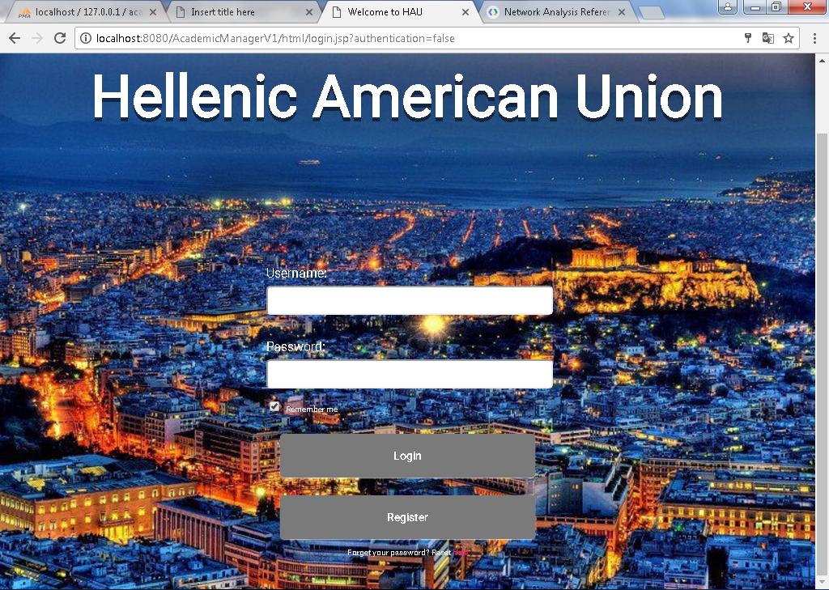

Login Behavior

* In case the user does not provide any credentials, the message “Username or password is empty !!” will appear.
* In case the user enters an invalid combination of username/password, a popup window will alert that “username or password is incorrect, please try again.”

The Registration process and the “Remember Me” option are not yet implemented. Currently, new users can only be created by the system administrator.



Blank Credentials



Invalid Credentials

1. Secretary
   1. Secretary Home page

After successful login, the main secretary page appears.  
Secretary can select to view all the available courses, students or teachers.

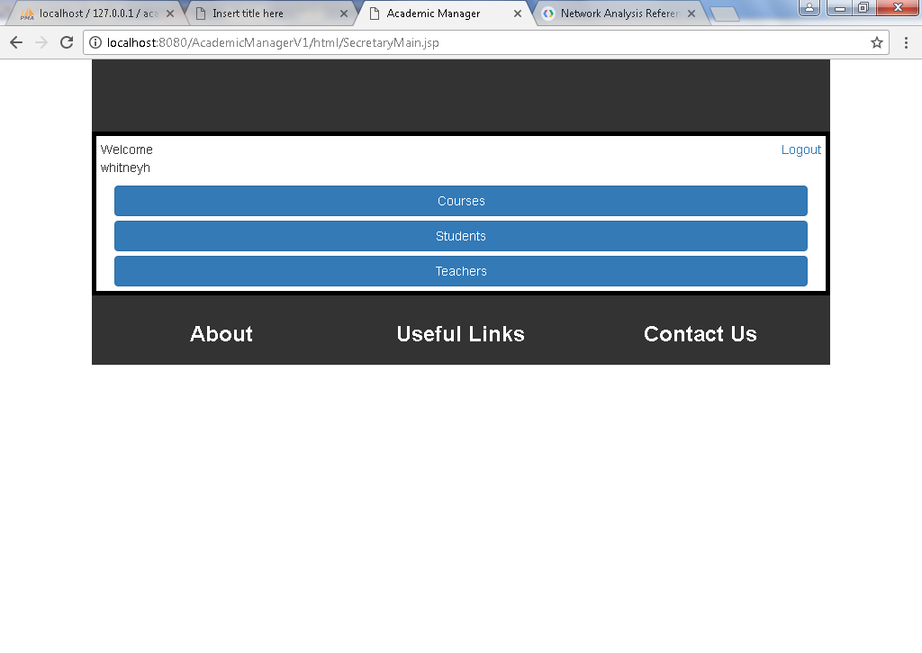

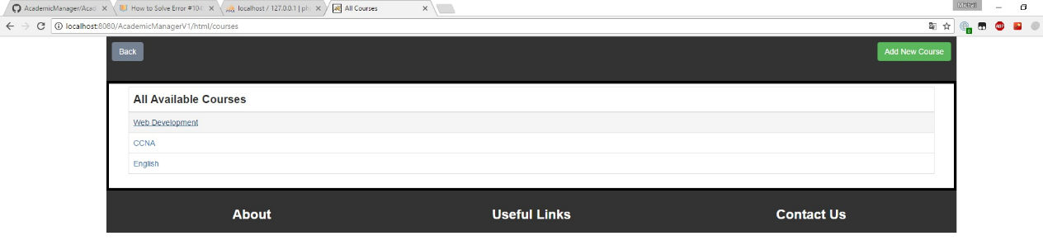

By selecting one of them, we get a list with all available data. By clicking on one of them, we go to the details page of the selection.

It is also possible to add a new entry by selecting the “Add New” button on the top right corner.

* 1. Course Details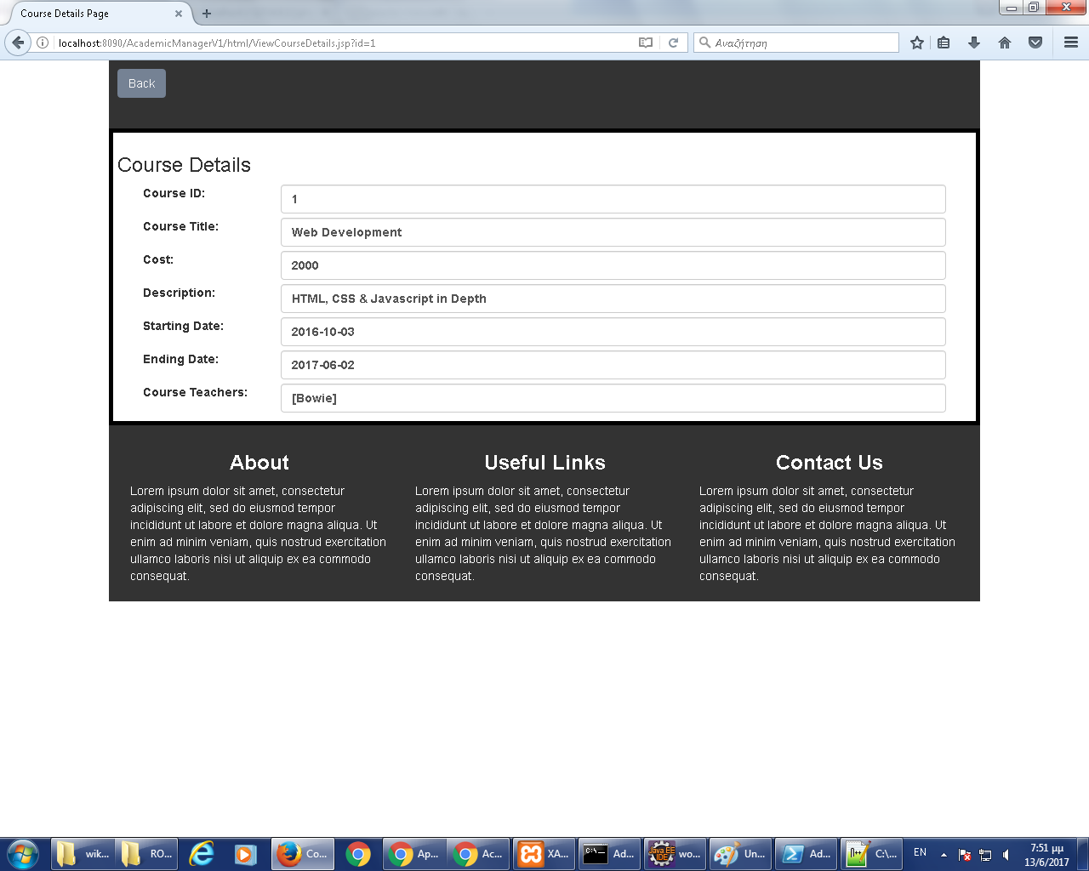

Adding a new course:

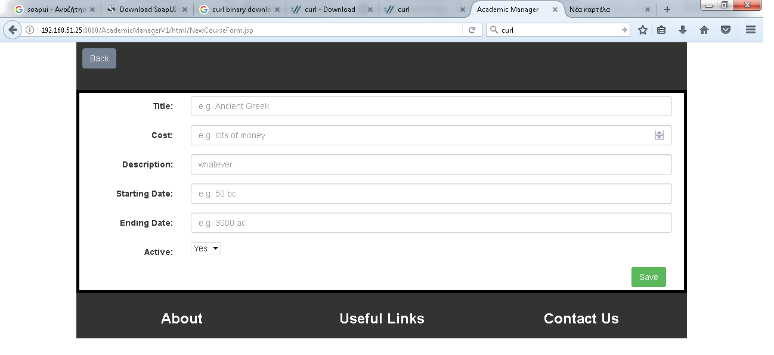

Editing/Deleting a course:

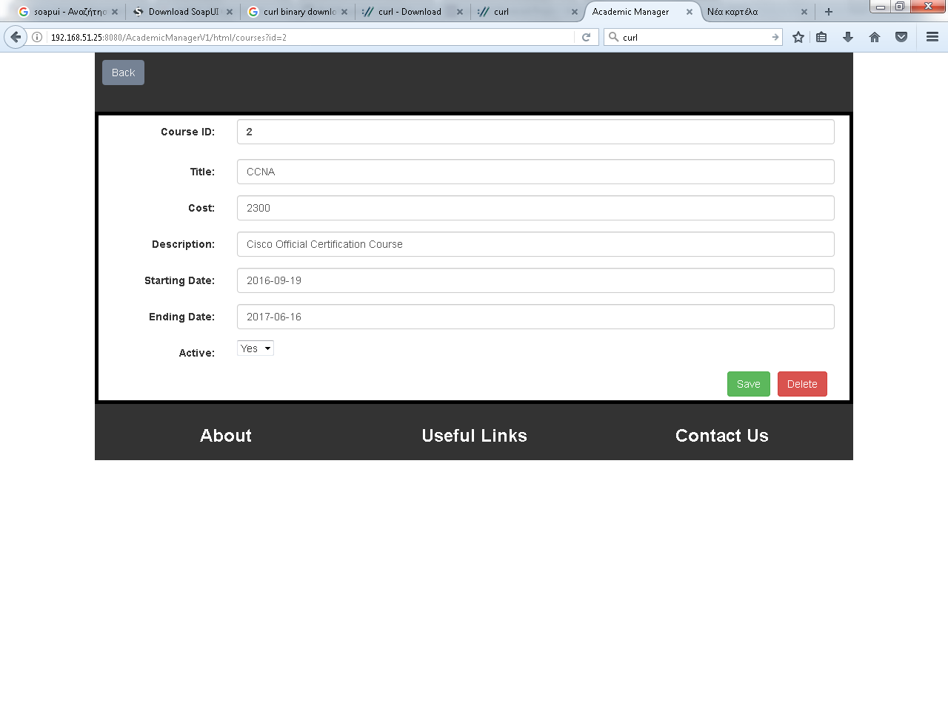

Adding a new student:

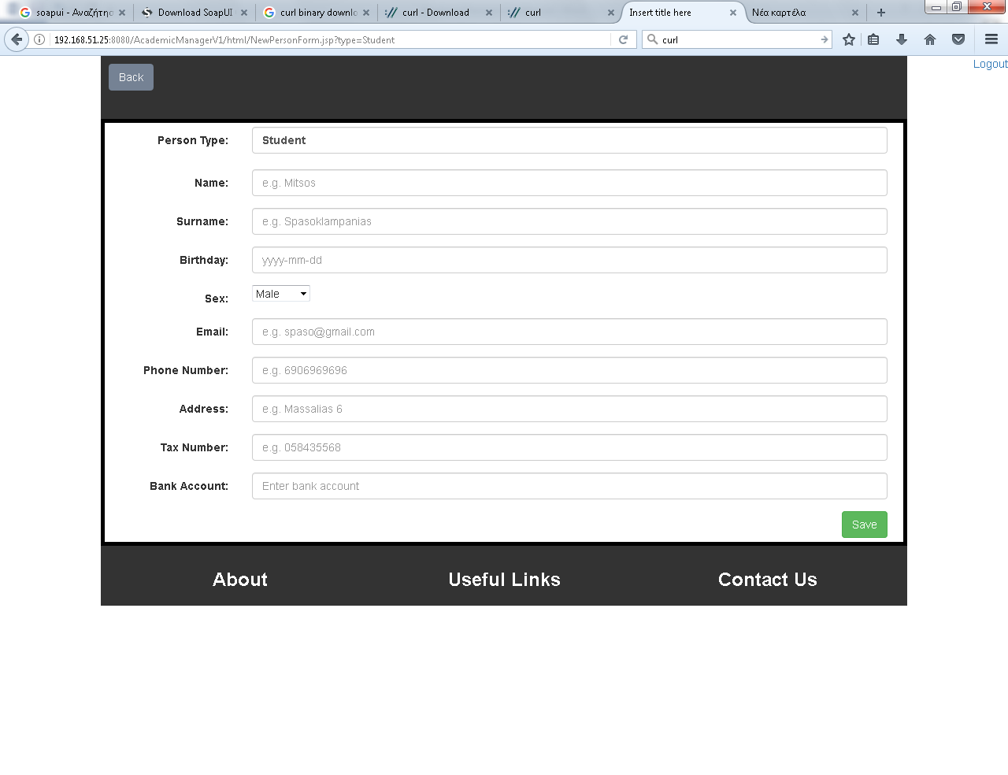

Editing/Deleting a new student:

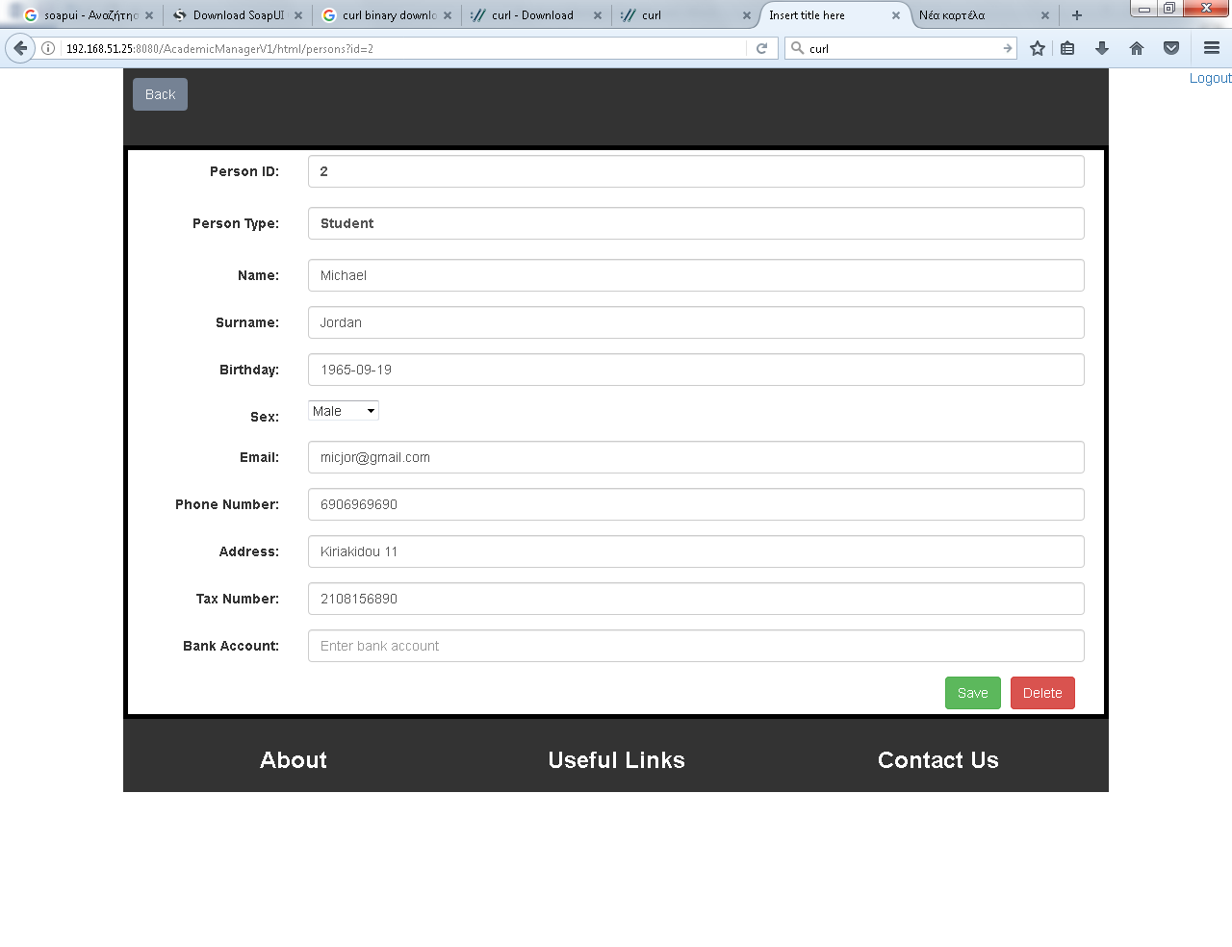

The same logic is applied to the add/edit/delete a teacher.

# Web Services

The application exposes a RESTFul API with the following endpoints. Currently only the GET HTTP WebMethods are implemented.

1. Course Details :

Endpoint: …/rs/courses

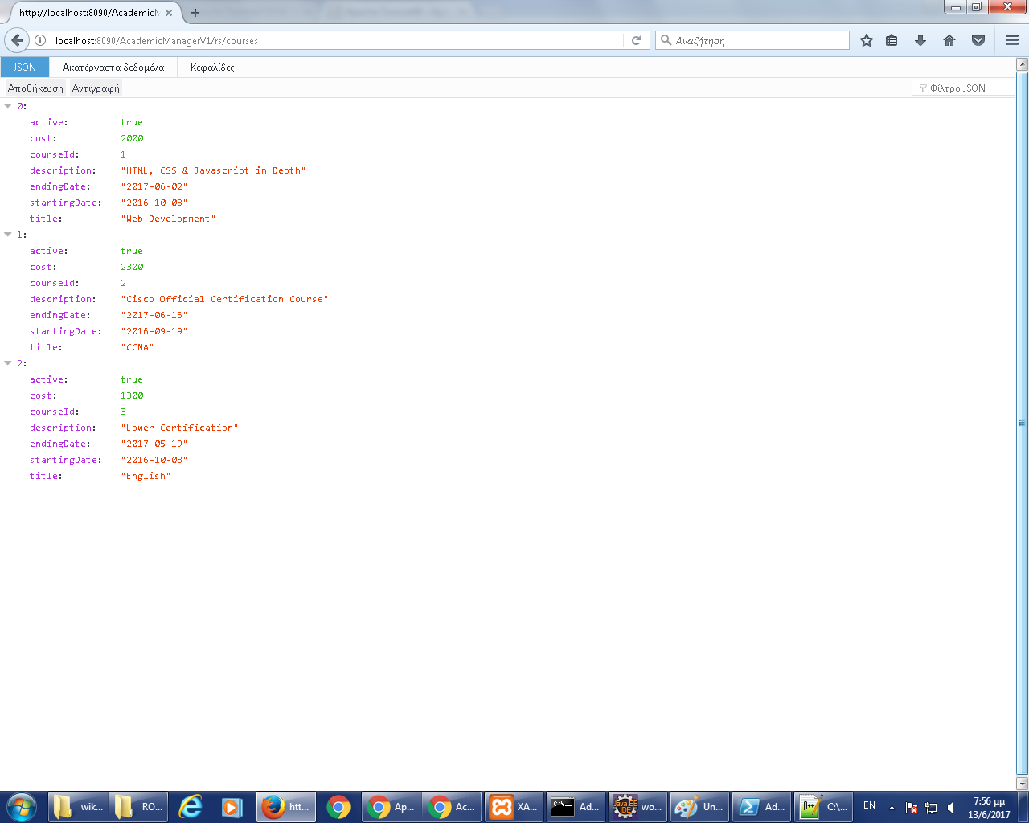

1. Teachers List:

Endpoint: …/rs/teachers

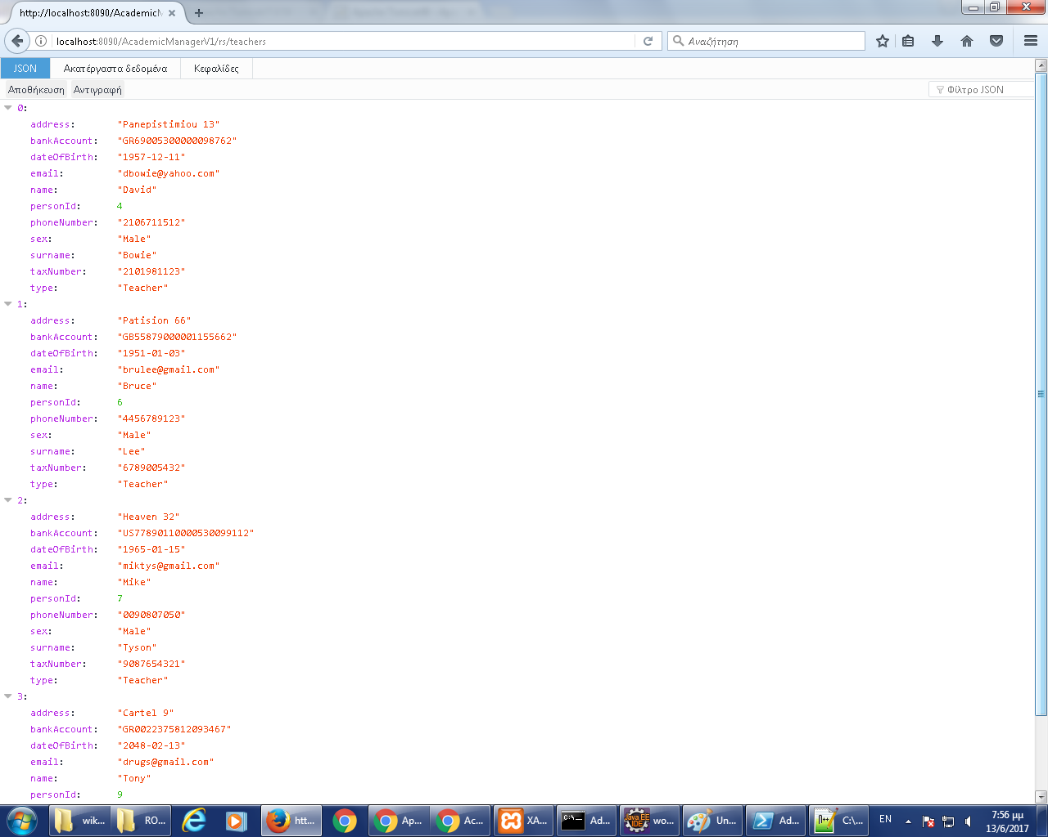

1. Teacher Courses :

Endpoint: …/rs/teachers/<id>/courses

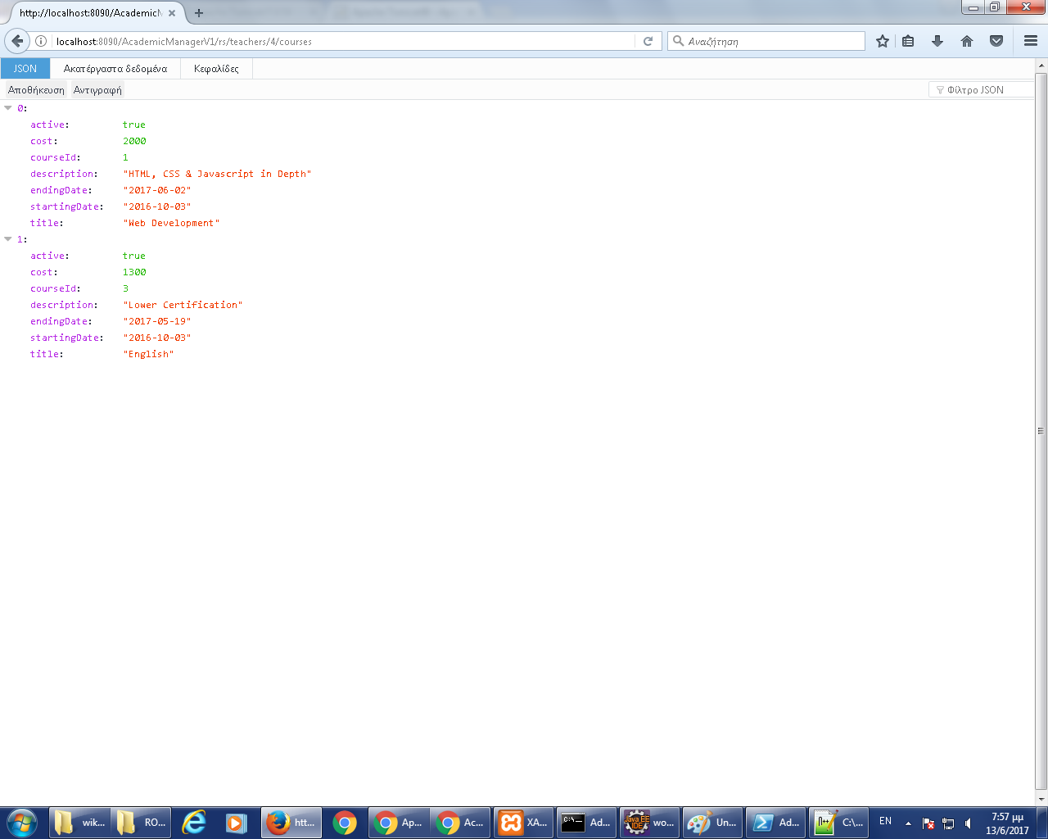

1. Teacher Details:

Endpoint: …/rs/teachers/<id>

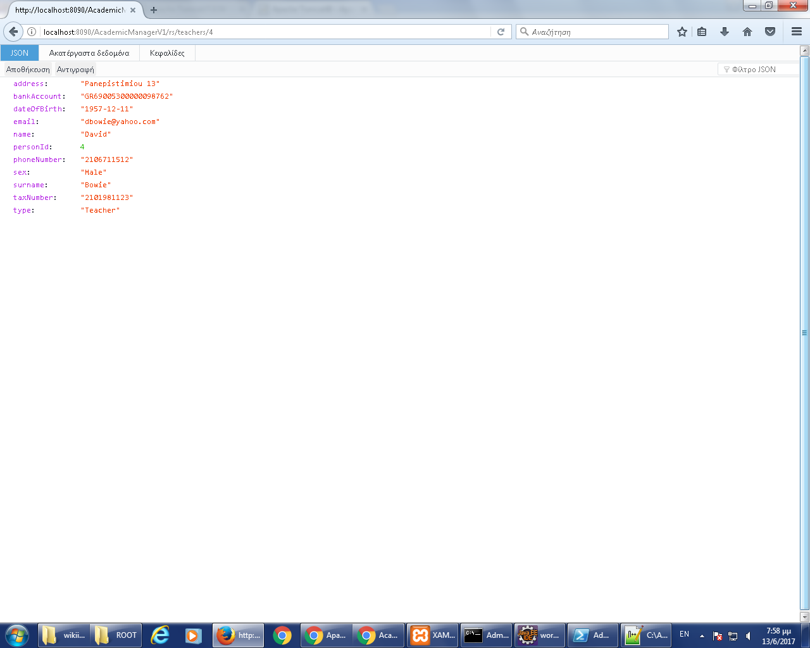

A final use case: Consuming the courses service, using alternative clients: SoapUI and curl.

Using SoapUI:

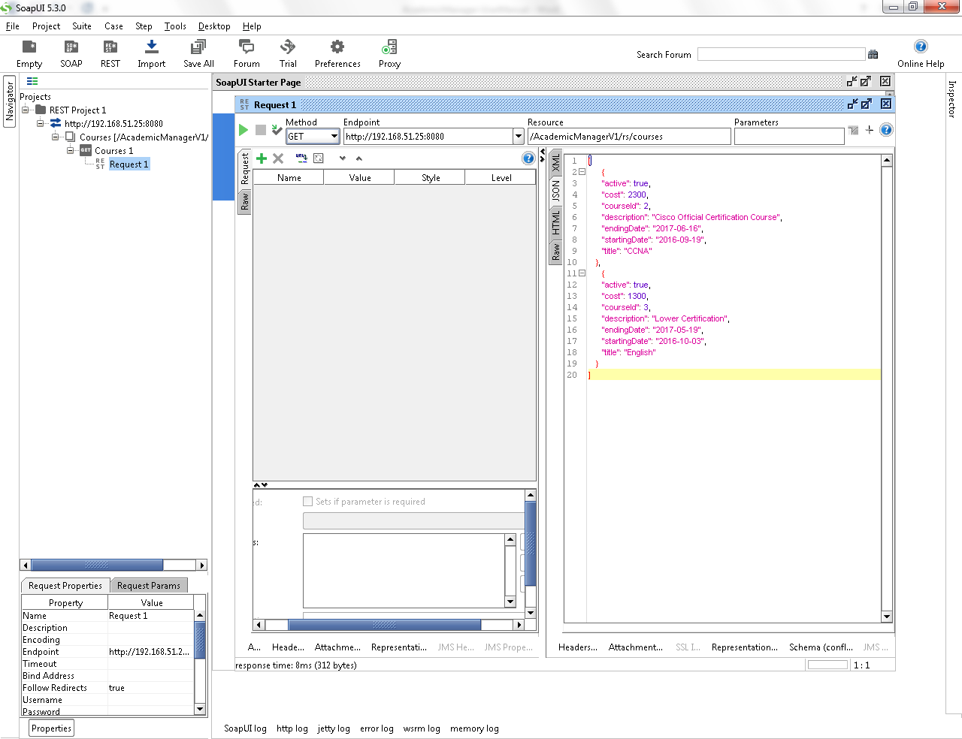

Using curl:

